KHALILULLA HUSSAINI 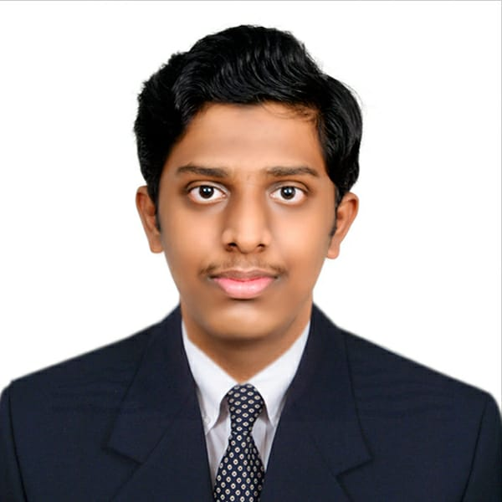

Email: 0603khalil@gmail.com

Contact Number: 9731883071

Objective:

Seeking a challenging career in a reputable organization that provides an opportunity to expand my learnings, knowledge and technical skills. Secure a responsible career opportunity to fully utilize my training and skills

Education Qualification:

|  |  |  |  |  |
| --- | --- | --- | --- | --- |
| Course | Institute | University | Year of passing | Percentage of marks obtained/CGPA |
| BE (Civil Engineering) | SDM college of Engineering & Technology | Autonomous College under VTU, Belagavi | 2022(pursuing) | 7.15% |
| PUC | Emirates Future Intl Academy, Abu Dhabi | CBSE BOARDS | 2018 | 65% |

Academic Projects:

1. Minor Project Report on Application of Smart materials in Civil Engineering,

This project is aimed at monitor the civil engineering structures to evaluate their durability.

Monitor the integrity of Bridges, Dams, offshores oil drilling towers where fiber-optic sensors embedded in the structures are utilized to identify the trouble areas.

1. Extensive Survey

(a) NEW TANK PROJECT

Finding capacity of reservoir

* With using Contour Maps

1. Highway Project

* Finding reduced level with using Profile levelling

Technical Skills:

* Auto Cad
* Basics of C Language
* Basic skills: MS word, MS excel & various communication skills.

Hobbies:

Reading books, Gardening, travelling,Photography,

Music.

Personal Details:

Father’s Occupation: Engineer (B.E Mech)

Mother’s Occupation: Doctor (B.H.M.S)

DOB: 6/3/2001

Languages known: English, Urdu, Hindi

Address: Azad Nagar,near noorani masjid,Behind Vanita

Sewa Samaj

Dist.: Dharwad

Pin:580001

Declaration:

I hereby declare that the above information is true, correct to the best of my knowledge.